2026 Australasian Law Academics Association (ALAA)
Conference
GALA DINNER
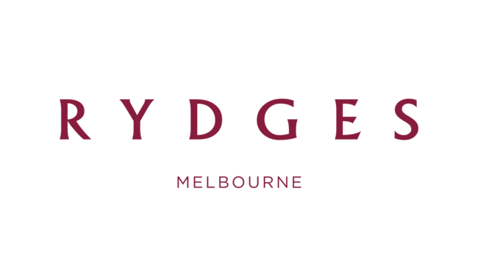
Join colleagues and friends at Rydges Melbourne for an elegant evening of dining, connection and celebration of the successful nominees for the 2026 CALD Academic Awards.

THURSDAY 2ND JULY, 7pm
RYDGES MELBOURNE, 186 Exhibition Street, Melbourne
Semi- Formal.

A SEAT AT THE GALA DINNER IS INCLUDED IN CONFERENCE REGISTRATION.

SECURE YOUR SEAT BY REGISTERING FOR THE CONFERENCE HERE!

ADDITIONAL GALA DINNER TICKET CAN BE PURCHASED HERE!

Evening Program TBC

Getting There:
186 Exhibition Street, Melbourne.
Public Transport
5-minute walk from Parliament Station via Lonsdale St and then Exhibition St.
Directions
If travelling from the airport, travel along the Tullamarine Freeway and take the left turn into Flemington Rd when the city. At the roundabout, continue straight ahead onto Elizabeth St. Turn left at Victoria Parade and right into Exhibition St. The Rydges Melbourne hotel is on your left.
A taxi is approximately $70 and a 30 min drive. Shuttle service is approximately $22 and a 1-hour drive and can be booked through SkyBus.

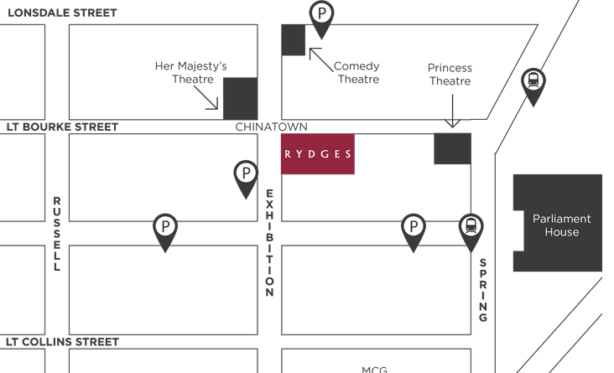

Parking
Rydges guests can enjoy on-site parking for $60 per day. Simply take a ticket to enter the car park. When you’re ready to hit the road, pre-pay for your parking at reception, and we’ll provide you with an exit ticket to use on your way out.
For non-guests, parking is $45 and musts be paid at reception prior to leaving the event.
To exit the car park, scan your exit voucher to open the boom gate.
Rydges Melbourne car park is open daily from 6 am till midnight. Exit after this time is still available for in-house guests. If you experience any issues, please contact our team on +61 3 9662 0511. Parking is subject to availability.

Please advise when registering if you have any dietary requirements.
Email enquiries to alaa-2026@unimelb.edu.au .
